**40. Design NFA to accept any number of b’s where input={a,b}.**

**AIM:** To design NFA to accept any number of b’s where input={a,b}.

**TRANSITION DIAGRAM:**

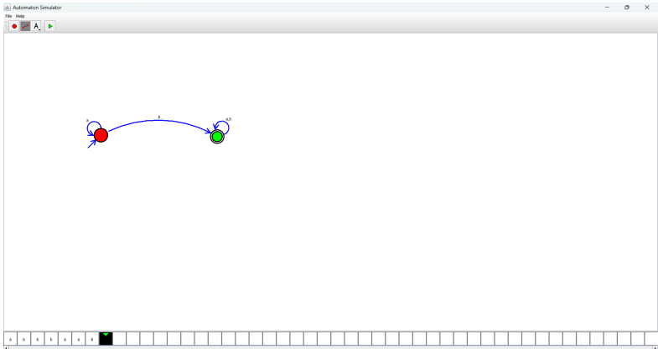

**RESULT:** Hence designing NFA using a simulator to accept any number of b’s